Mr. St. Pierre Name_______________________________ Date_______________
Graphic Novels
Non-fiction Project
Graphic novels and comics have been adopted by nearly every genre, and one of the most progressive uses of graphic novels is in the genre of non-fiction. To explore how comics can be used in non-fiction, we will create our own non-fiction comics. All the steps to this project are listed below. Please follow closely. This project needs to have at least 20 panels.
- The first stage requires research. You will need to choose a non-fiction topic to research. This topic can be anything from a figure you admire, to a recent event, to a current event, to a past event. We will brainstorm ideas in class but once you decided, we will spend time in the library. You must have three pages of notes gathered from at least three sources. This should be completed in your journal.

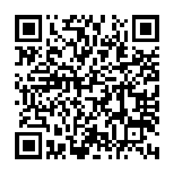
- After you’ve conducted your research, you will need to create a story synopsis. Check out the journals for an explanation and sample of the story synopsis. This code will bring you directly to a sample. Your story synopsis should be at least four paragraphs. This should be completed in your journal.

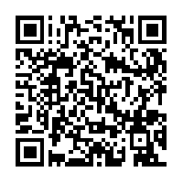
- Once your story synopsis has been approved, you need to create a page synopsis. Check out the journals for an explanation of the page synopsis. This code will bring you directly to a sample. Your pages synopsis should describe at least 4 pages. Keep in mind this project needs to have at least 20 panels. This should be completed in your journal.

- After the page synopsis is approved, you will need to create a storyboard in your journal.

- Once your storyboard is approved, you will complete a final product, using whatever means you choose, that needs to have all of the following elements:

A variety of typography
A reveal for each page
At least 5 elements from “The Disney Method” handout
Synecdoche
Establishing shot
At least 5 different ways of framing
Understandable flow
At least 3 different kinds of text/image relationships
At least 3 different kinds of transitions
At least 2 inserts
A holistic page
A creative layout
Awareness of visual rhythm

Your final product needs to reflect good effort and pride in your work. It needs a title as well as your name, period, and date, at the top. It should also be perfectly edited. All errors will result in 1 point deduction each from your grade.

